Github link: <https://github.com/KendrickBaker/csd-340>

Github Repository:   
  
  
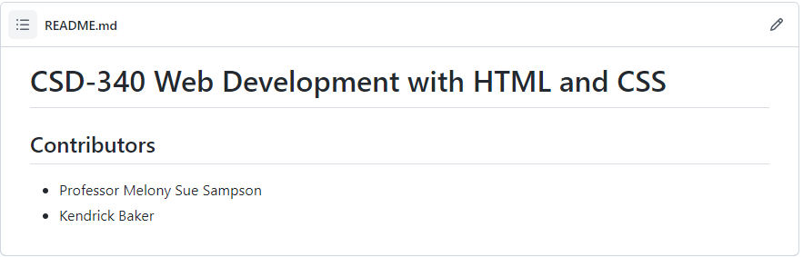

Local Directory:

